# 1. SYSTEM REPORT FOR JS SOCIAL MEDIA SITE

Contents

1. SYSTEM REPORT FOR JS SOCIAL MEDIA SITE 1

1.1PseudoCode 2

1.2 Methods and Classes 2

1.2.1 Login Method 2

1.2.2 ShowLoginForm Method 2

1.2.3 Preview Image Method 2

1.2.4 Show Signup Form Method 2

1.2.5 User class 2

1.3 System Screenshots 2

Figure 1 Landing Page 3

Figure 2 Sign Up form 3

Figure 3 Home Page 4

Figure 4 Profile View 5

Figure 5 Account Details 6

## 1.1PseudoCode

This is the pseudocode of the main JavaScript File of the Social Media Site

BEGIN

signUp = ArrowFunctionExpression not implemented

FunctionDeclaration not implemented

END

## 1.2 Methods and Classes

### 1.2.1 Login Method

This Method fetches the user-entered information from the html form and verifies along with the user credentials. It will then take the user to the main page

### 1.2.2 ShowLoginForm Method

This method is used to display the login form when the user clicks the login button

### 1.2.3 Preview Image Method

This method is what allows the user to get a preview of the profile image before uploading it fully

### 1.2.4 Show Signup Form Method

This method will open up the signup form when the user clicks the sign up button

### 1.2.5 User class

This is the class that is used to initialize the user object and contains all the attributes and methods the user will need

### 

### 1.3 System Screenshots

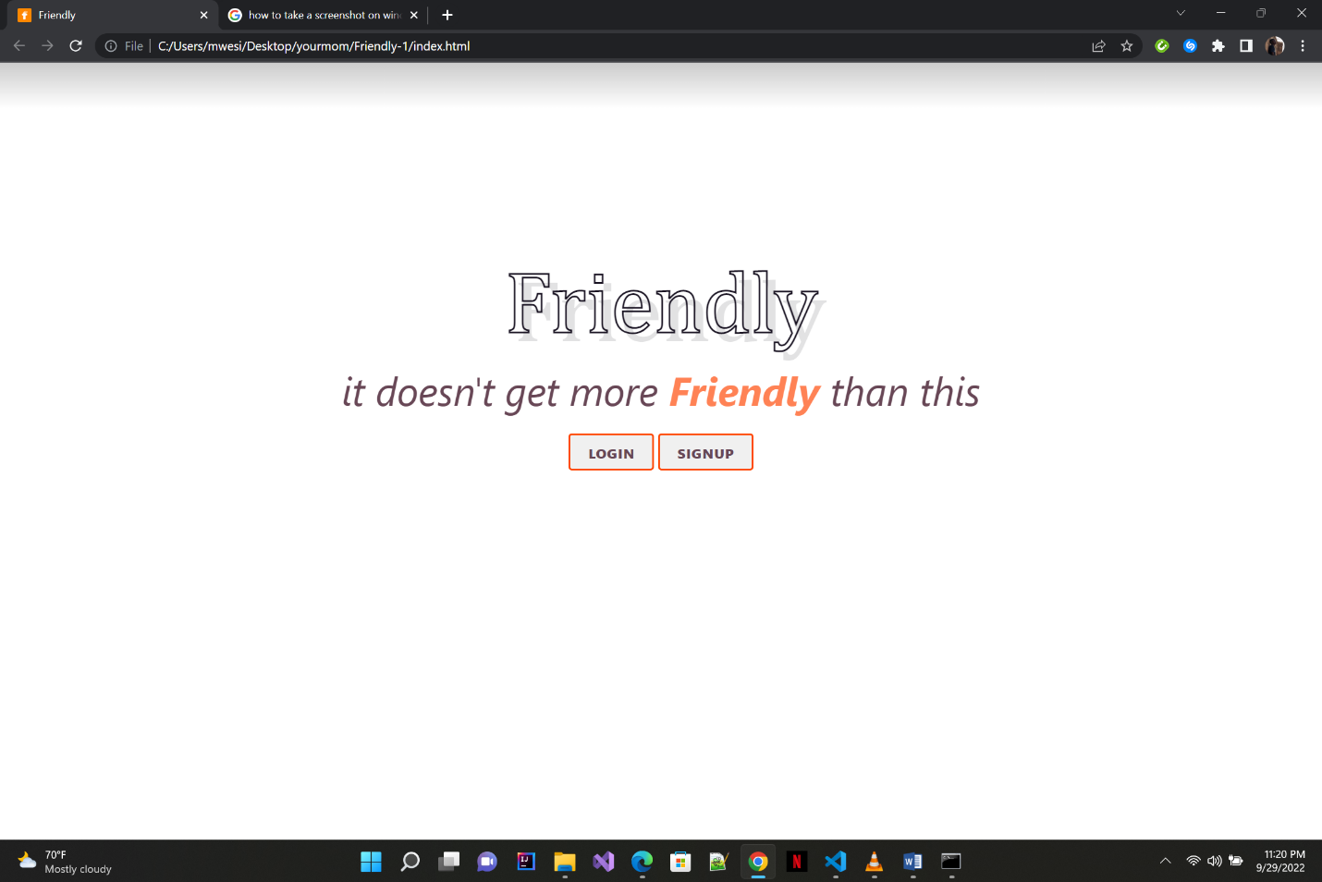

Figure Landing Page

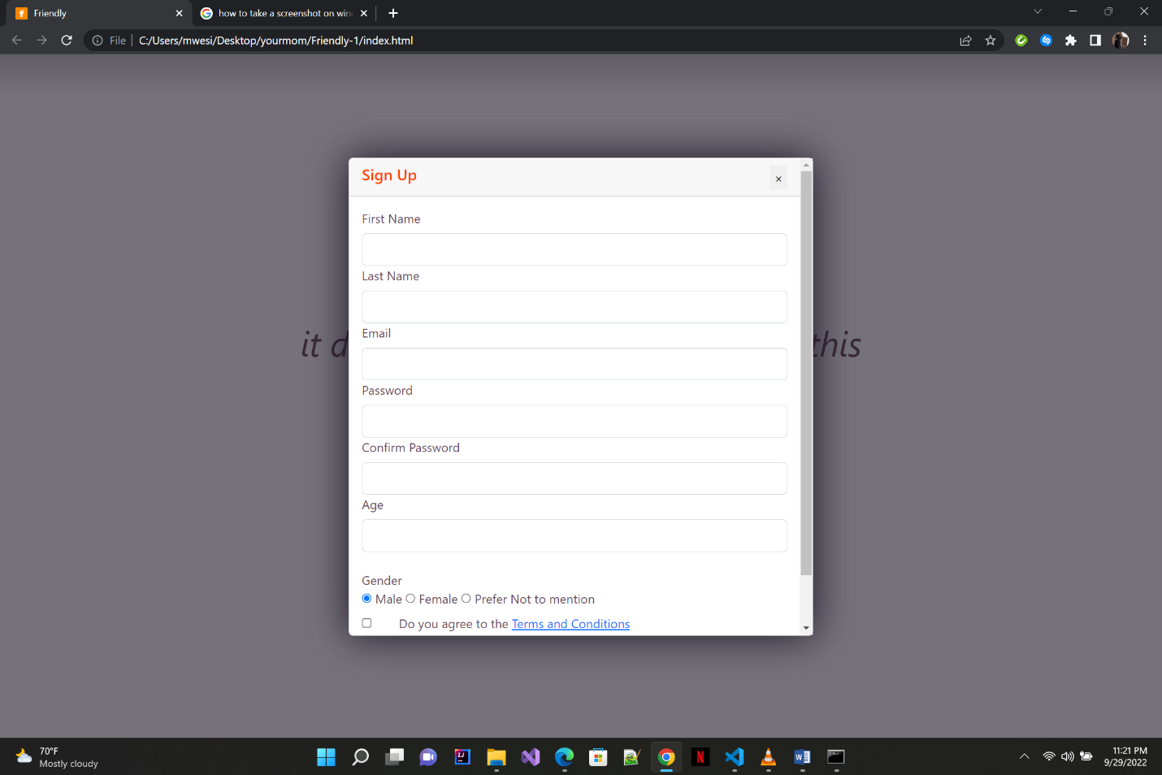

Figure Sign Up form



Figure Home Page

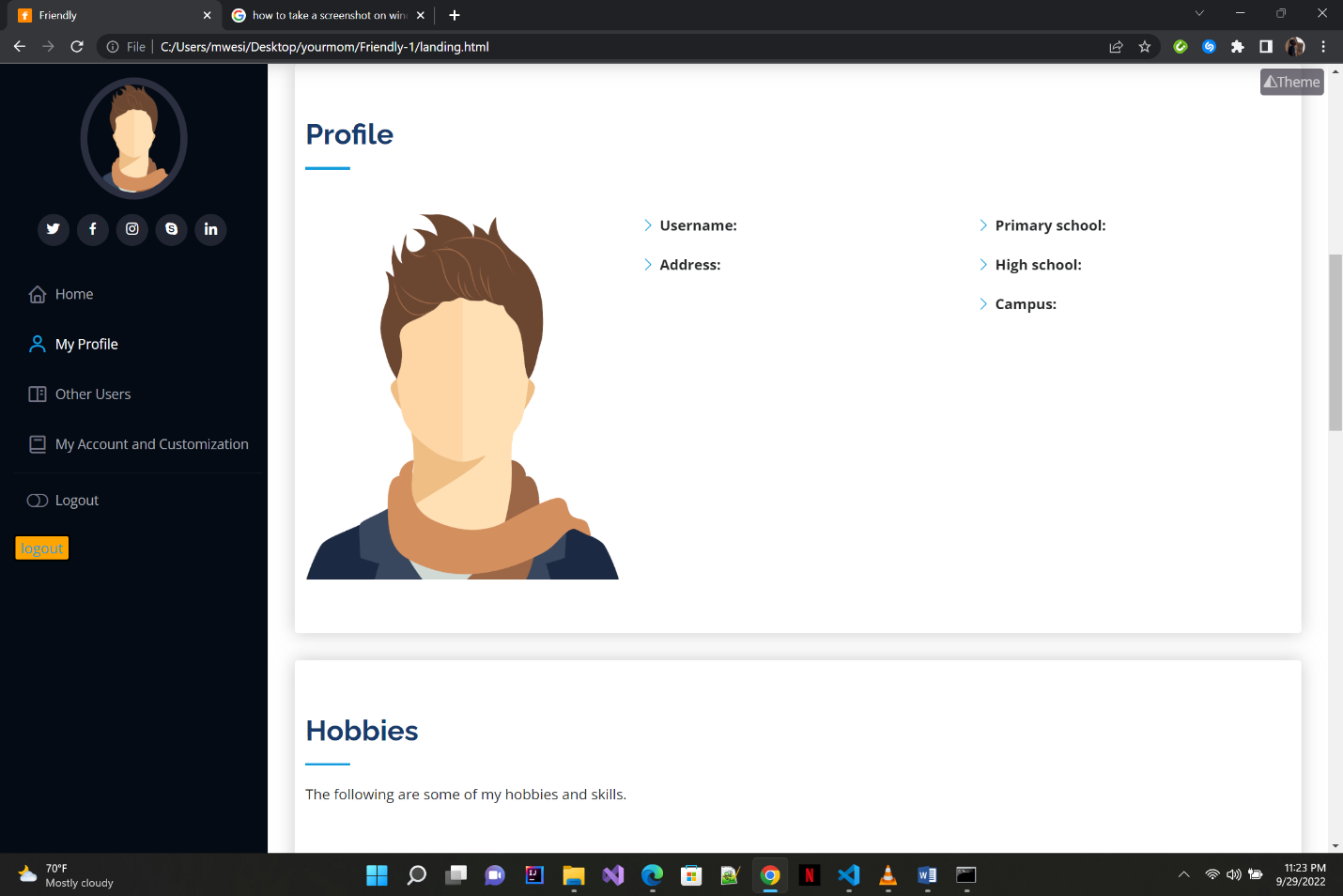

Figure Profile View

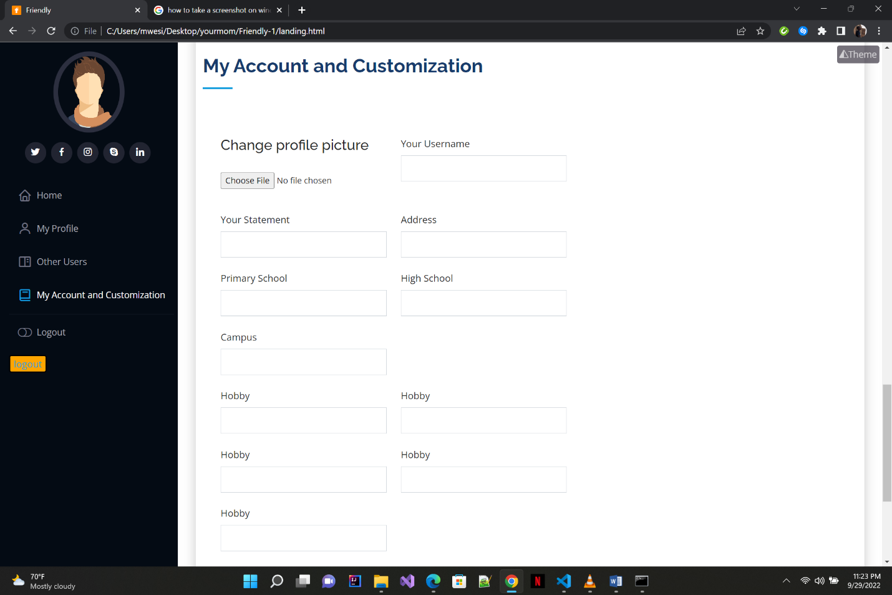

Figure Account Details